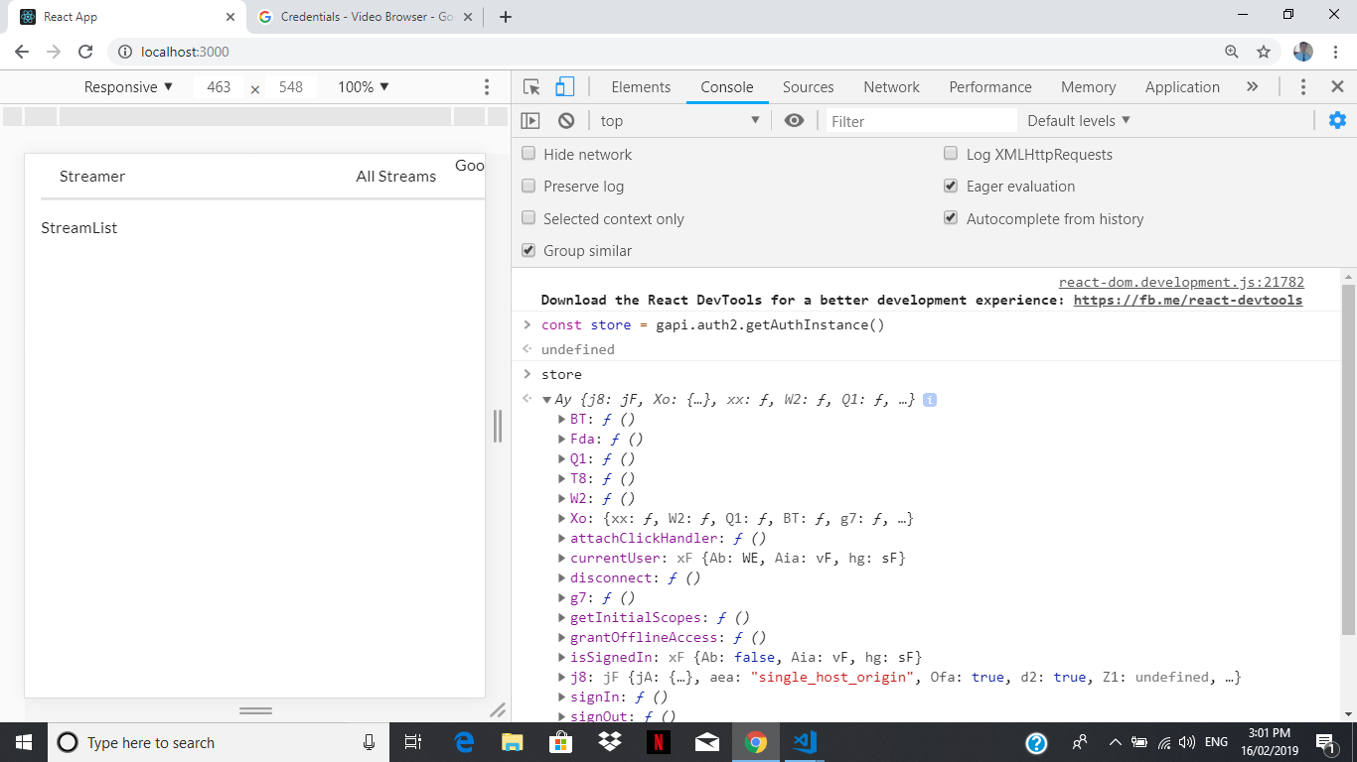

This signIn is obtained from google api oAuth documentation:

<https://developers.google.com/api-client-library/javascript/reference/referencedocs>

### select reference>go down to gapi.auth2.getAuthInstance()

### check if someone or you have been signedIn

### use:

### store(whichever variable you assigned to gapi.auth2.getAuthInstance()).isSignIn.get()

### should return true if you/someone have signed in

### also gapi can also check signedIn userId

### 

Console error : “you have not enable cookie in this current environment”

“idpiframe initialization error on Chrome”

**Fix by : unblock** “block third party cookies”

